Python Assignment
Name: Saisha Jadhav
1. Grade Checker
Take a score as input and print the grade based on the following:
90+ : "A"
80-89 : "B"
70-79 : "C"
60-69 : "D"
Below 60 : "F"
here we used a basic if else statement to carry out marks and all.
Query-
score = int(input("Enter your score: "))
if score >= 90:
print("Grade: A")
elif score >= 80:
print("Grade: B")
elif score >= 70:
print("Grade: C")
elif score >= 60:
print("Grade: D")
else:
print("Grade: F")

Ss
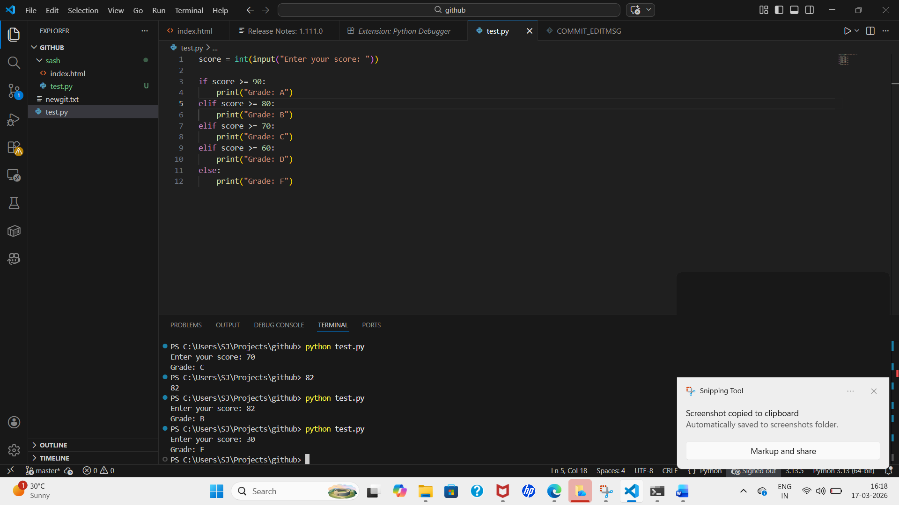

Explanation - This program takes marks as input from the user and uses if -else conditions to determine the grade. Based on the score range, it prints the corresponding grade.

2 Student Grades
Create a dictionary where the keys are student names and the values are their grades. Allow the user to:
Add a new student and grade.
Update an existing student’s grade.
Print all student grades.

Used dictionary and basic operations. Using if else:
code -
students = {}

name = input("Enter student name: ")
grade = input("Enter grade: ")

students[name] = grade

print("Student Records:")
for key, value in students.items():
print(key, ":", value)
ss
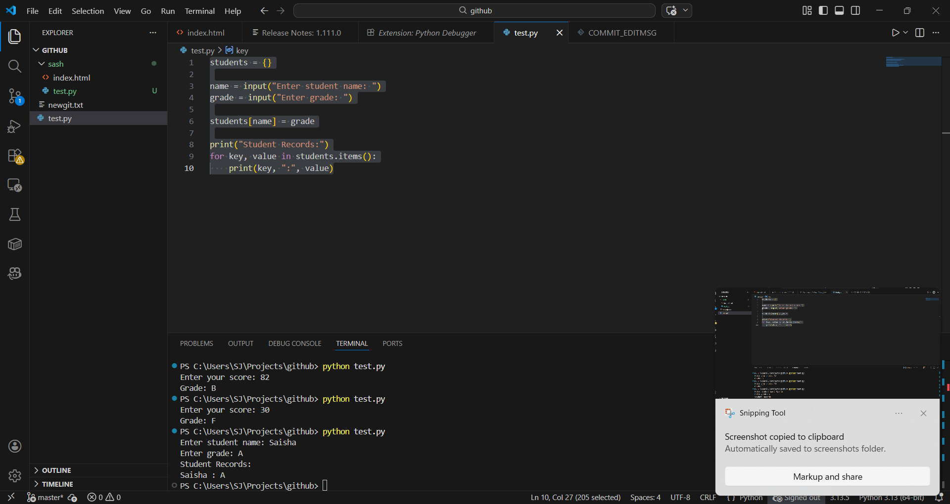

Explanation - This program uses a dictionary to store student names and grades. It allows adding student data and displays all records using a loop.

3.Write to a File
Write a program to create a text file and write some content to it.
Using file functions like write and open.

Code –

file = open("sash.txt", "w")
file.write("Yes sir")
file.close()
print("File written")
SS
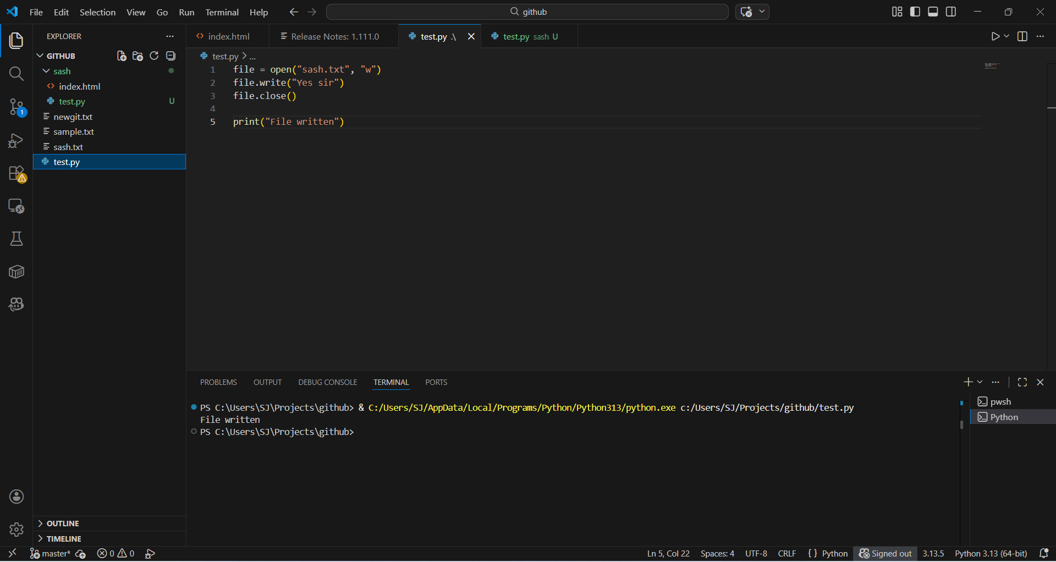

Explanation –
This program creates a file named sample.txt using write mode. It writes text into the file using the write() function. The content is saved after closing the file.

4. Read from a File
We used open in read mode and file.read to read and print to display.

CODE -
file = open("sash.txt", "r")
content = file.read()
print(content)
file.close()

SS
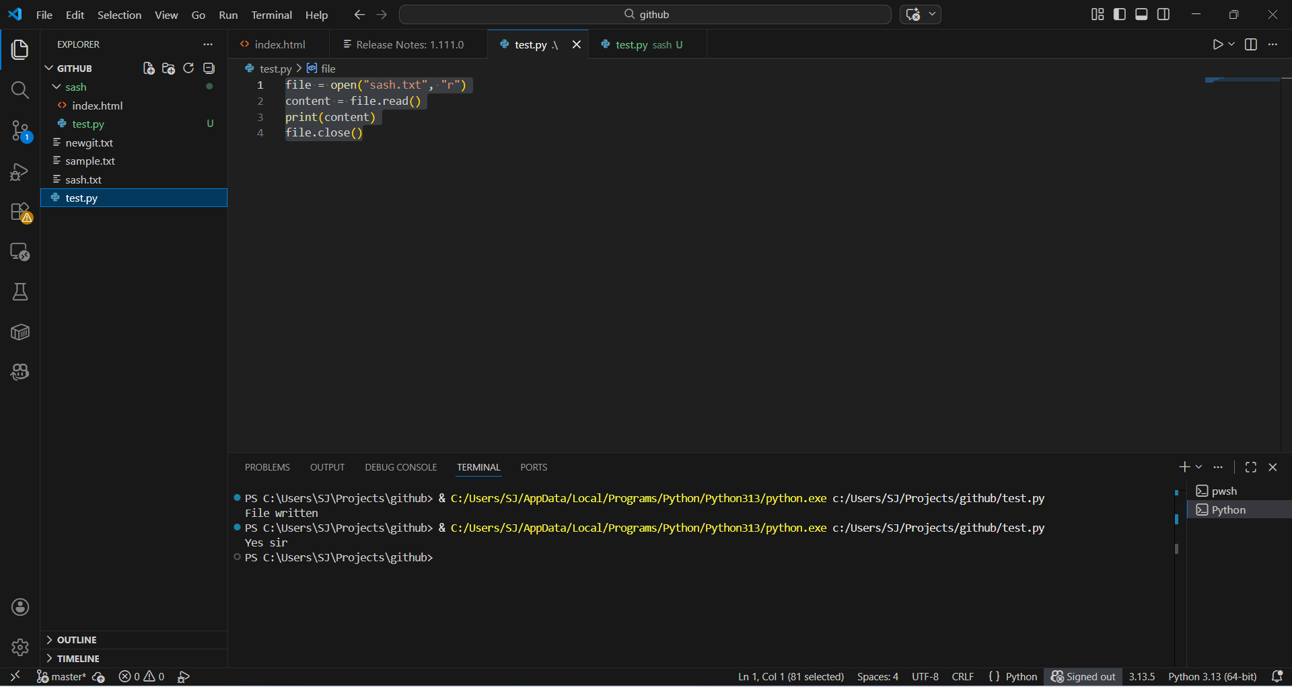
Explanation - This program opens a file in read mode, reads its content using read(), and prints it on the screen.

